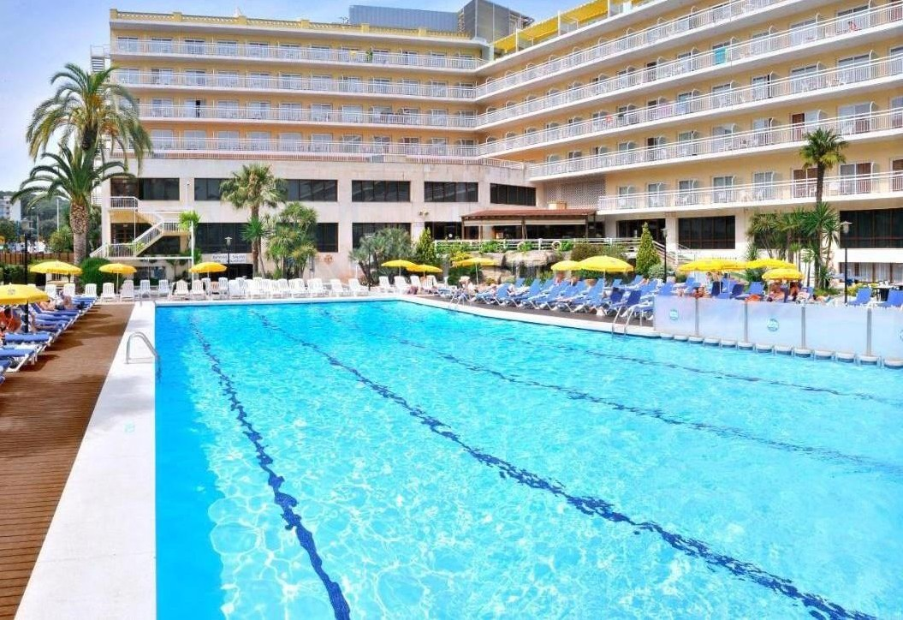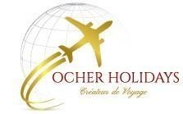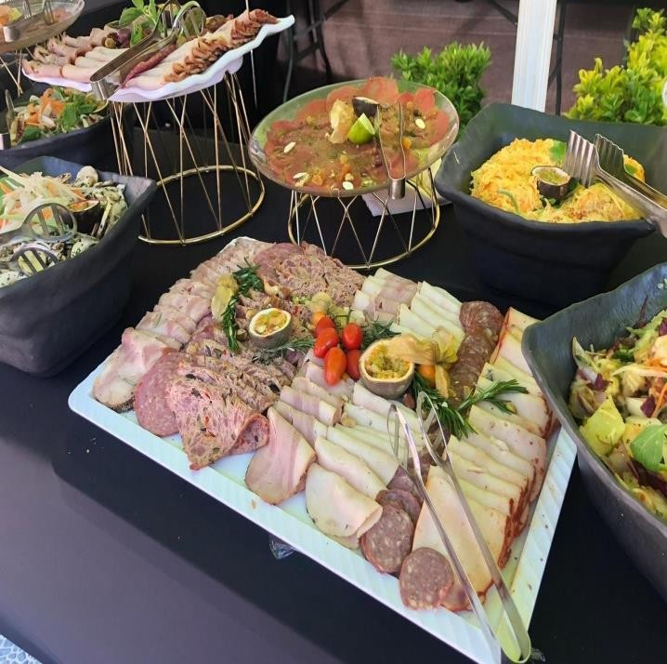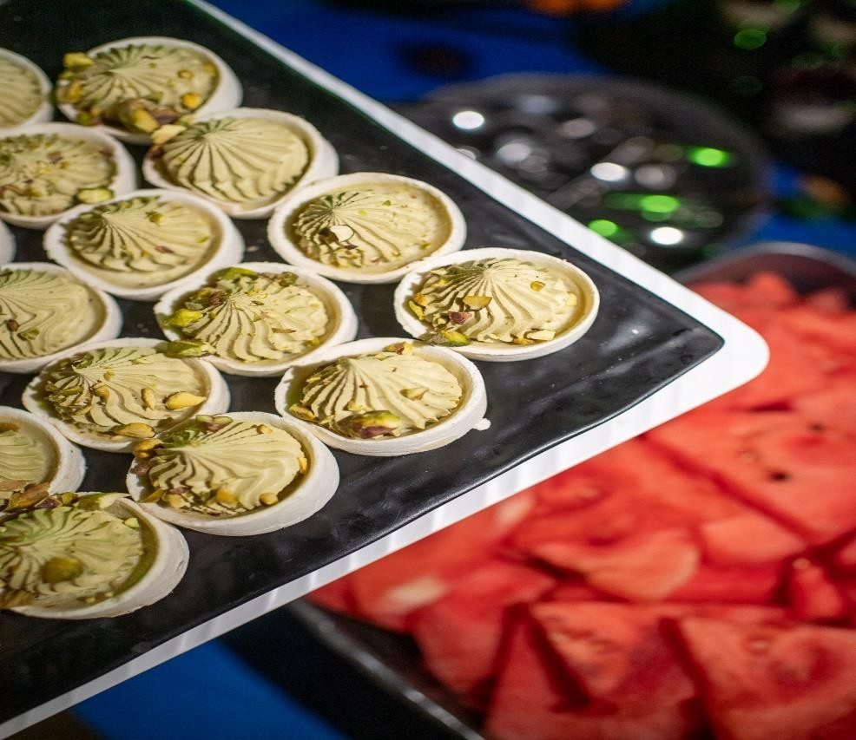
PASSOVER 5784

APRIL 21 TO MAY 1 2024

SOVER 2024 WITH OSHER HOLIDAYS 1

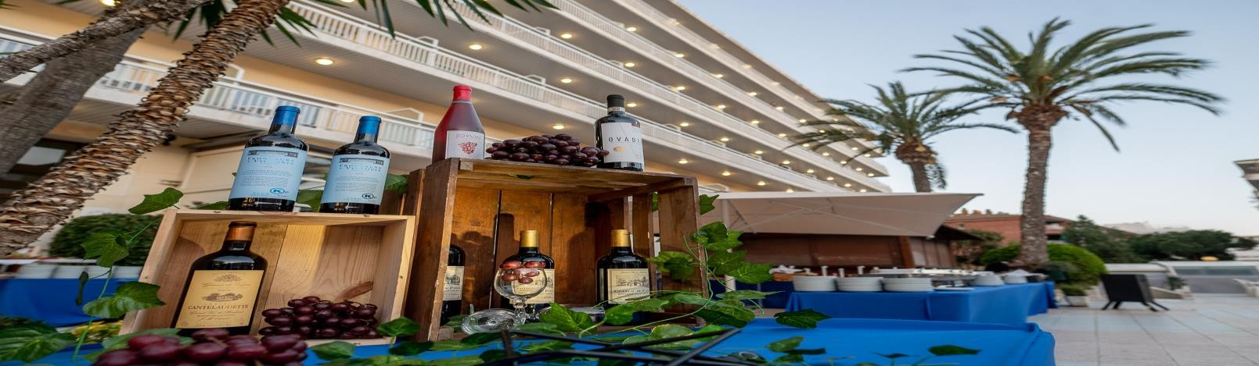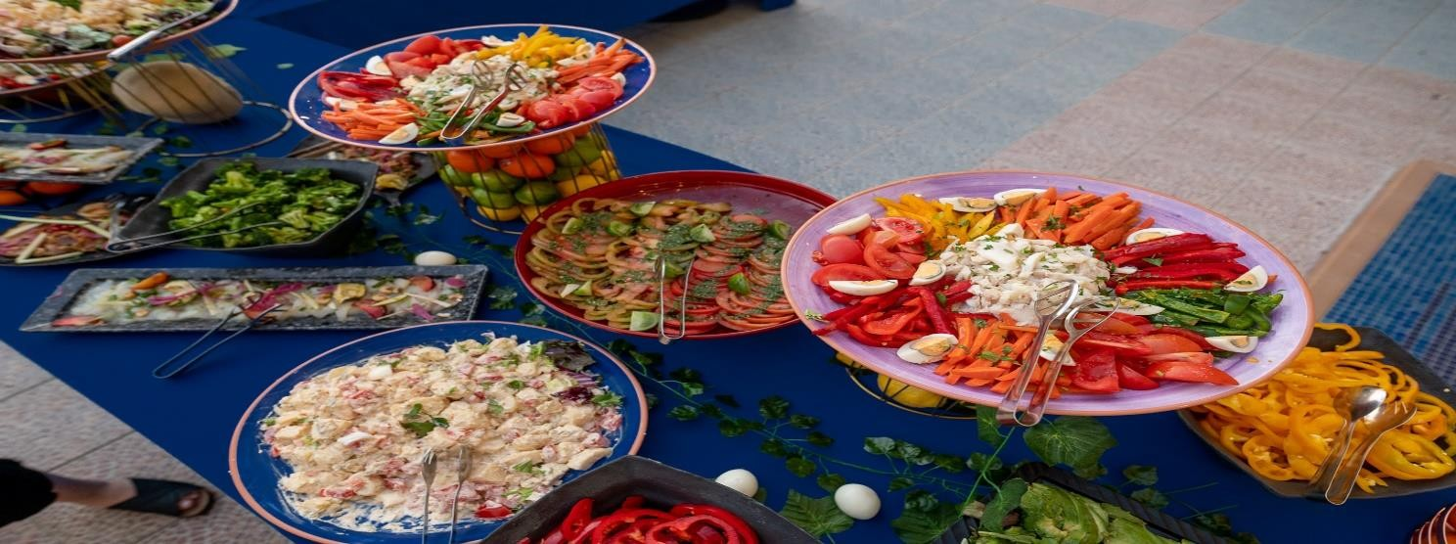

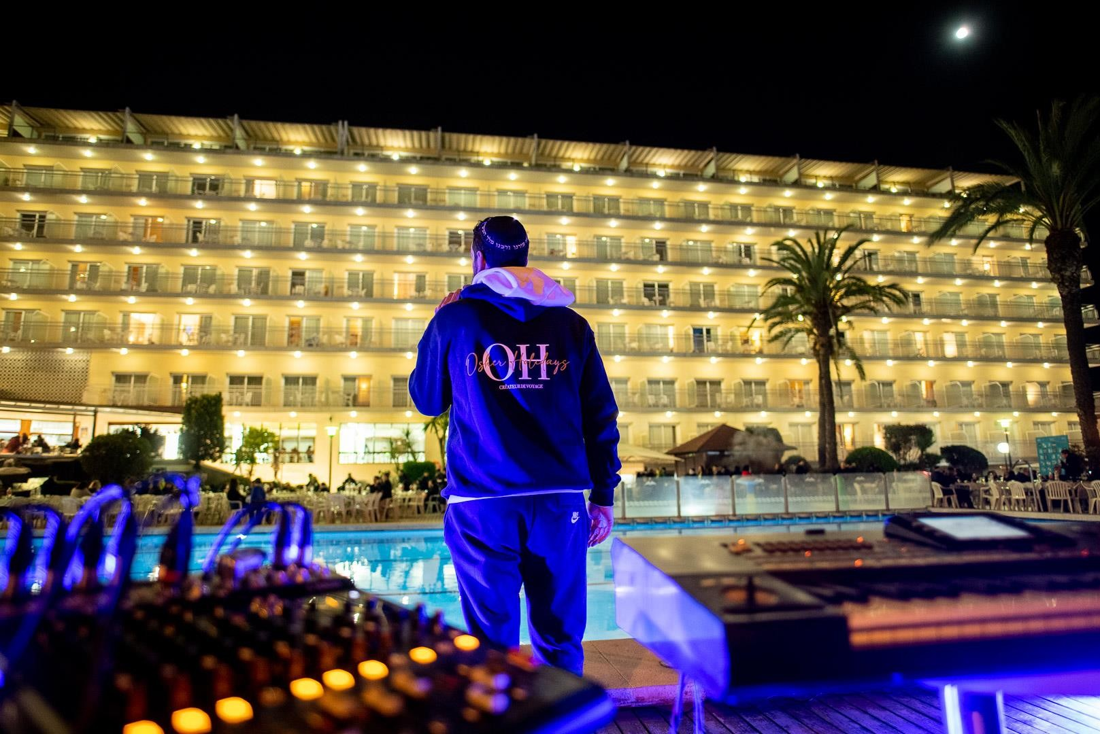
COSTA BRAVA SPAIN

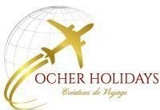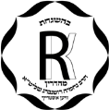OASIS PARK & SPA

No Kitniot

Rav Nehamia Rottenberg Israel GLATT KOSHER LAMEHADRINE
Luxe

Sunny Passover on the Costa Brava

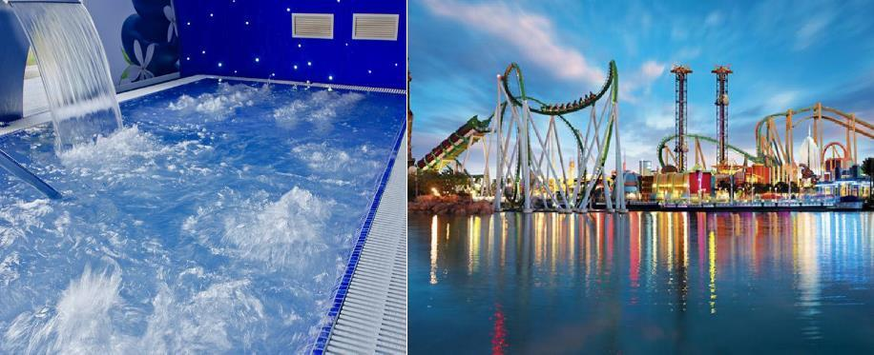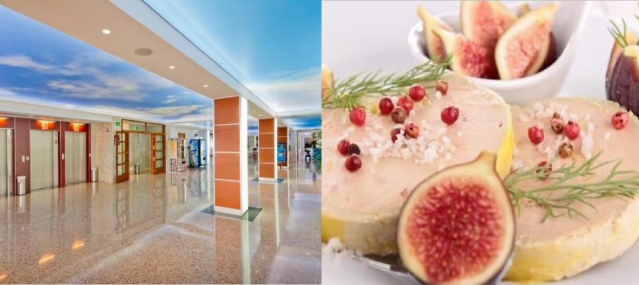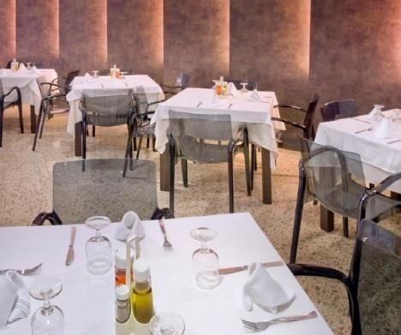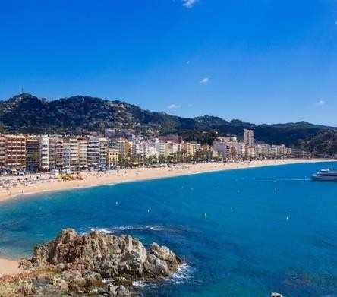 always sunny of the Costa Brava.
Park and SPA
Luxury
Oasis Park & Spa is located very close to Fenals beach and in the center of Lloret de Mar.
Offering suites, and a multitude of activities in the complex and nearby, this 4-star luxury hotel enjoys a convenient location privileged
PORTAVENTURA WORLD

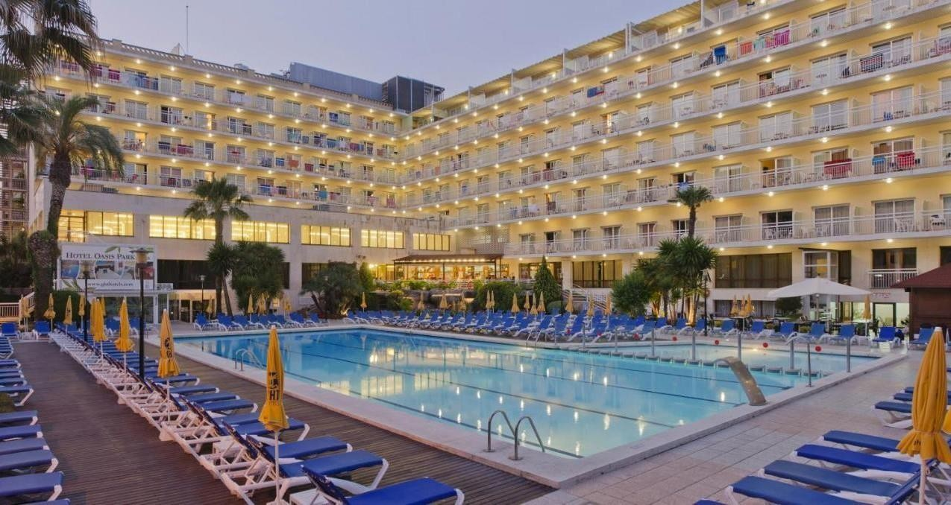

OASIS PARK & SPA ****Luxury
From 21th to 1th MAY 2024Lloret de Mar, located on the Costa Brava in the Spanish region of Catalonia, is known for its Mediterranean beaches. Lloret de Mar is also well known, with its lively nightlife, casino and many tourist sites. Offering beautifully appointed suites, a spa dedicated to the world of wellness, various restaurants and a multitude of activities available in and around the complex, this idyllic establishment enjoys a privileged and sunny location on the Costa Brava

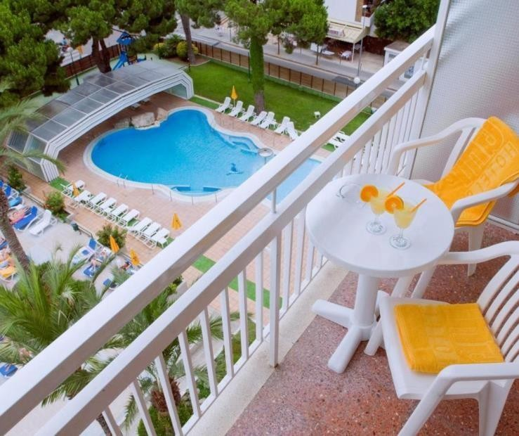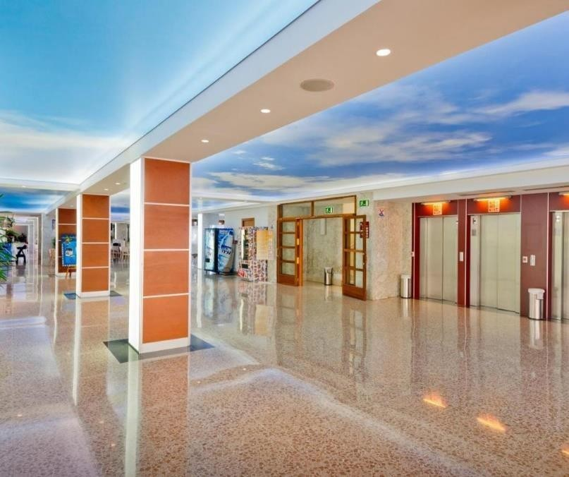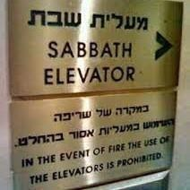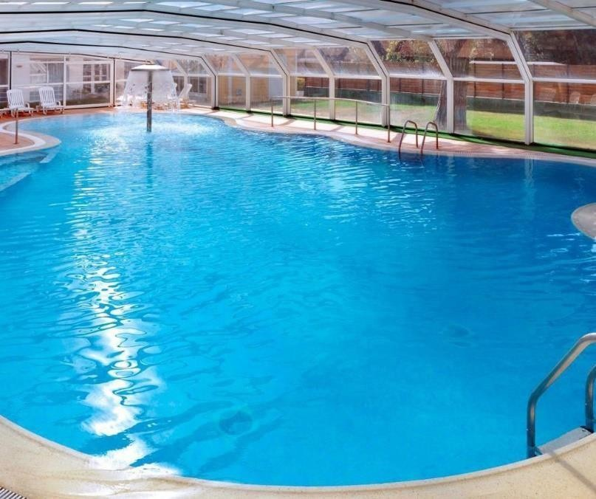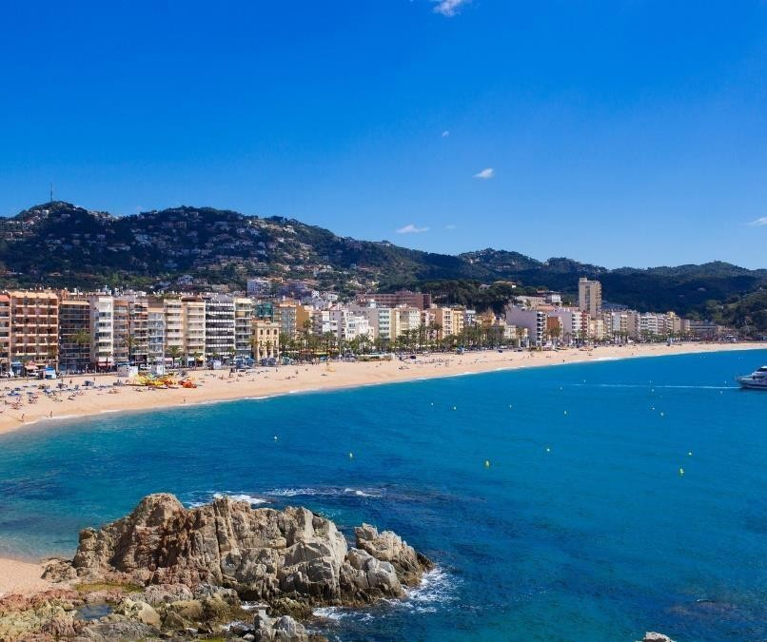

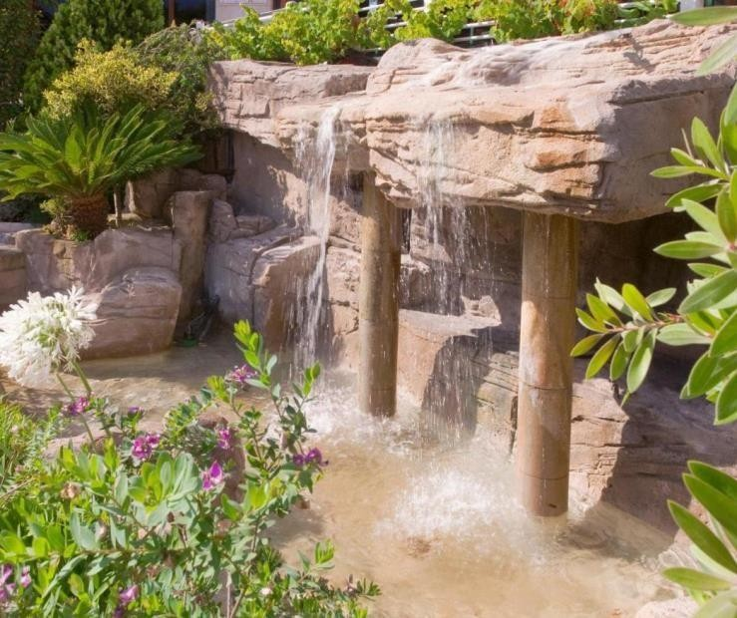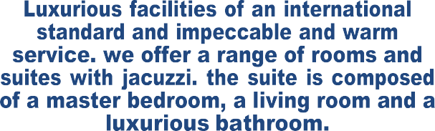
a perfect destination

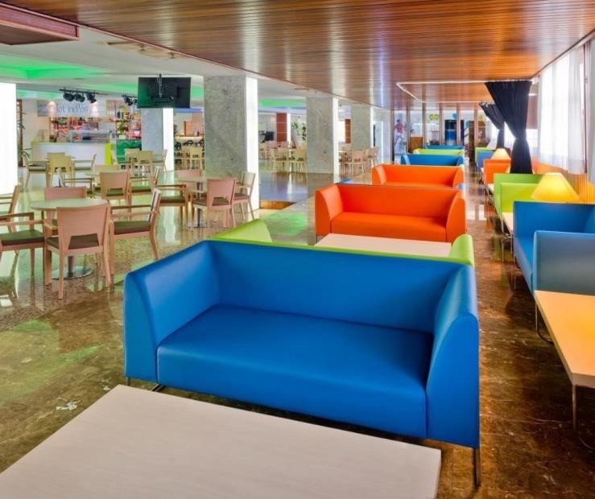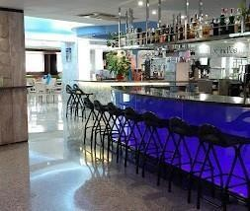

OASIS PARK & SPA
Luxe

Hospitality is alchemy. Ocher Holidays, and its Chef offers you high gastronomy, French and Israeli.
ALL INCLUSIVE, Glatt Kosher Laméhadrine,
under the strict supervision of Rav Nahamia ROTENBERG, (Yéroushalaim)
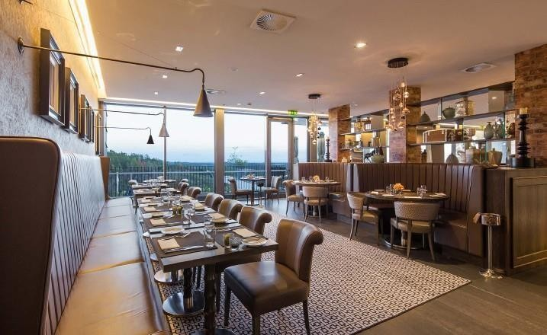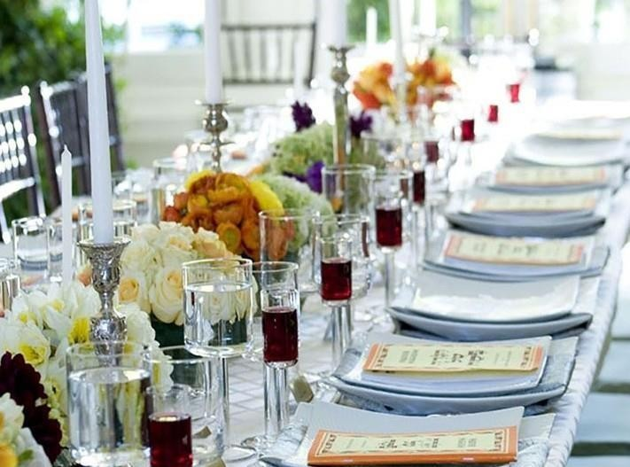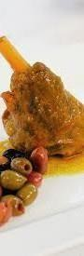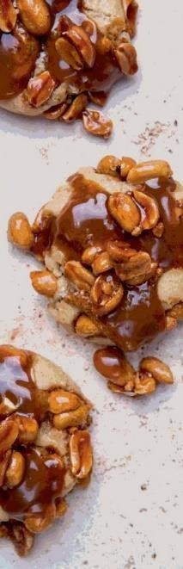

GASTRONOMIE
Glatt Kasher
During the day, a restaurant with an exceptional
In the evening an exceptional table for a Unique

In this unique place, French cuisine with a current signature but which draws its inspiration from the prestige and flavors of Israel.
More than a meal, it’s an experience Without forgetting the sublime desserts from our pastry chef, to satisfy all your desires

With family or friends, enjoy the tasty snacks served on our terraces facing the swimming pool. Meals are accompanied by quality wines. To choose from our selection, the best bottles will be offered to you.

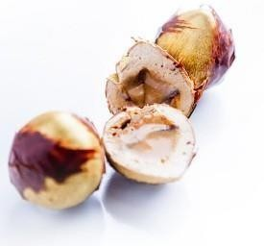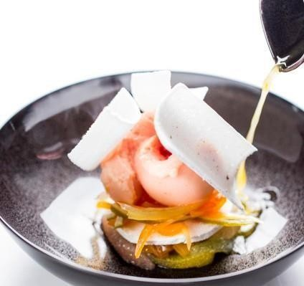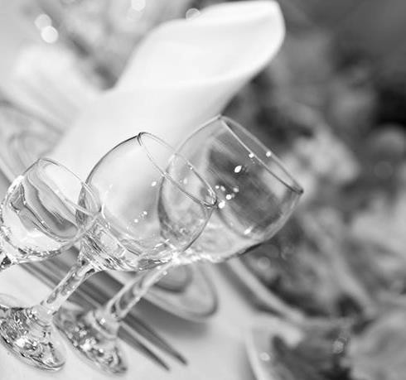

SEDARIM & CONFÉRENCES

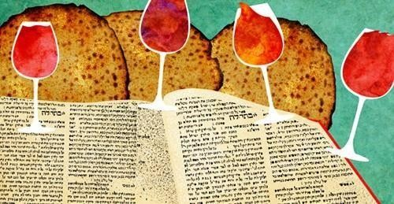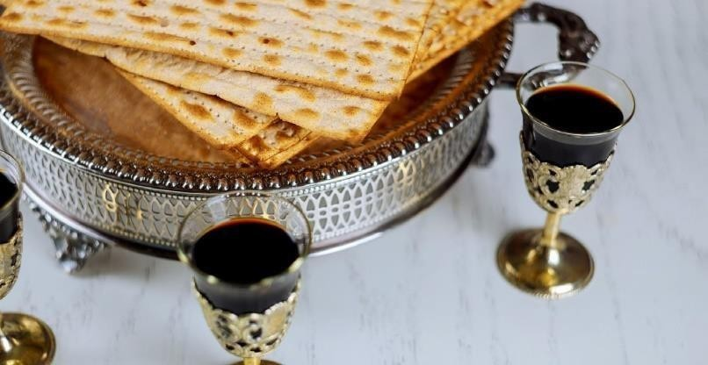

The particular character of each holiday is reflected by the name of the holiday, as well as by the Mitzvot, customs, and traditions attached to it. One of the culminating aspects of Passover is indicated to us by the name that the Anechei Knesset Hagdolah (Men of the Great Assembly) have given to this feast.
Zemane ‘Hérouténou, « the time of our freedom »

Rav Yaacov Gabbay, will do us the honor like this summer to lead the offices as well as the conferences throughout the stay

SEDARIM
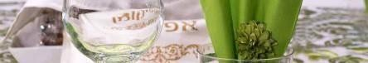
The two Passover evenings have become real moments of conviviality, proving that Passover can be celebrated with family as well as in community. For you we organize: A collective Seder, A private Seder keeping the particular character of each

CONFÉRENCES
Passover is also a time for reflection around TORAH & current topics. In these years of technological and health upheavals, the word of the great Torah masters is of crucial importance. We will have the pleasure of discovering their approach, their audacity and their choices.

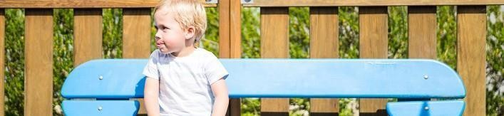Give your children an unforgettable vacation by taking part in lots of fun activities, in the hands of our friendly early childhood professionals. The Kids Club offers a wide range of activities to entertain children
PROFITEZ DE NOTRE PARC MINOAN

KIDS CLUB
from 3 to 12 years old. (from 10 am to 10 p.m.)

Children’s home and nursery
from 10 a.m. to 5 p.m.
Located in the complex, this children’s house is an oasis of tranquility. Our little guests can rest or play there in complete safety. At siesta time, beds and cradles for all ages are available. The walls are painted with characters who seem to be humming lullabies and whispering secrets to children. Healthy and balanced meals will be perfectly adapted to the nutritional needs of toddlers.

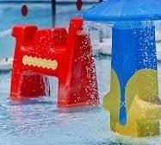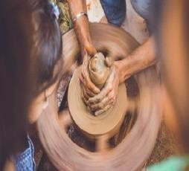Gan & Junior Club
from 10 a.m. to 9 p.m.
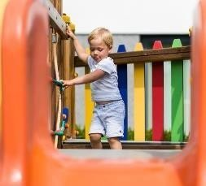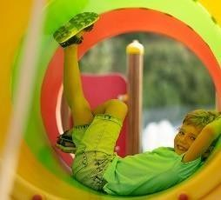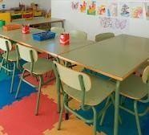Your children will be supervised by a team of BAFA qualified animators
A breathtaking program....
Trampoline, outdoor and indoor swimming pool, games room, pottery, games, theaters (indoor and outdoor) football
The outdoor family pool offers our little guests the pleasure of endless water games. Kids will love the kids’ club with its multiple activities

unique and adventurous holidays

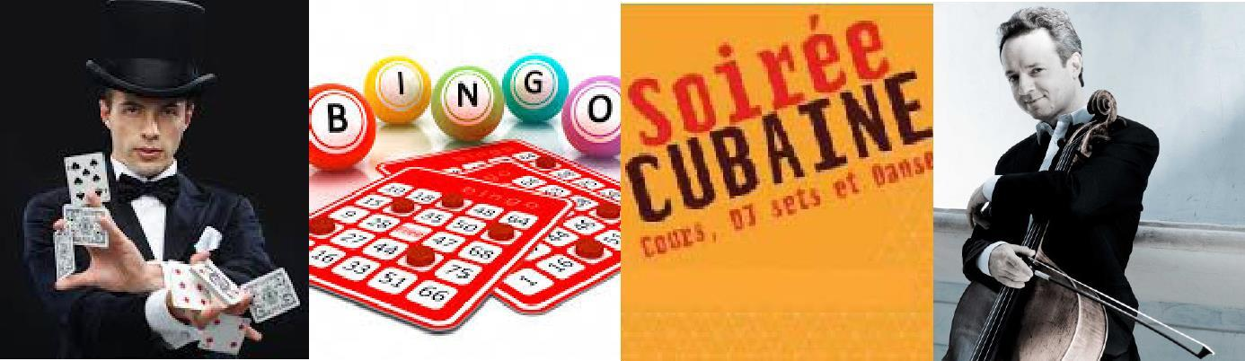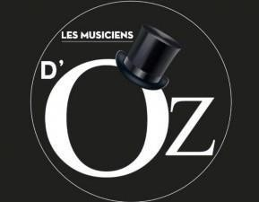EVENINGS & ENTERTAINMENT

Ocher Holidays, and Les Musiciens d’Oz will make your evenings exceptional and unforgettabl moments
Laughter, wonder, surprises, emotions, enthusiasm, between concerts, magic, games around the pool, quiz evening, let yourself be carried away throughout your stay, by the enchanting appointments of our team of animators.

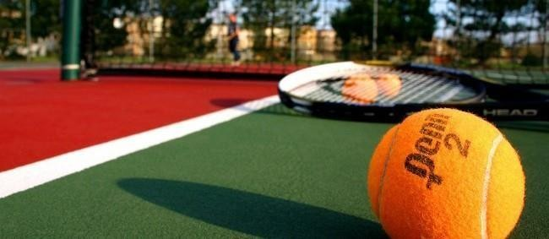
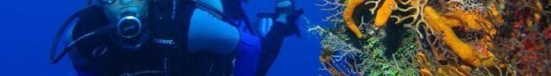Throughout your Passover stay, we have many activities in store for you inside and outside the Resort. We will discover the Costa Brava with its most beautiful beaches in Spain

ACTIVITIES
Tennis, billiards, table tennis, outdoor chess, swimming competition and water polo match as well as many activities are also available to guests.

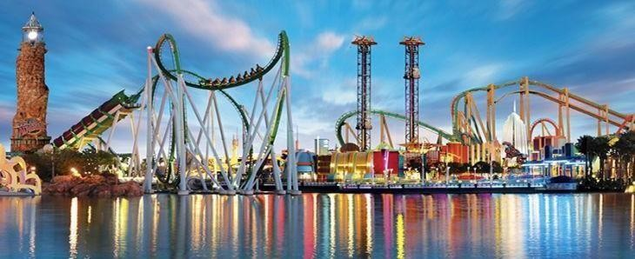
PARKAVENTURA
Discover all that the best family amusement park in Europe has to offer, A few minutes from the hotel explore a magical and fun world, filled with unforgettable moments. pool slides.

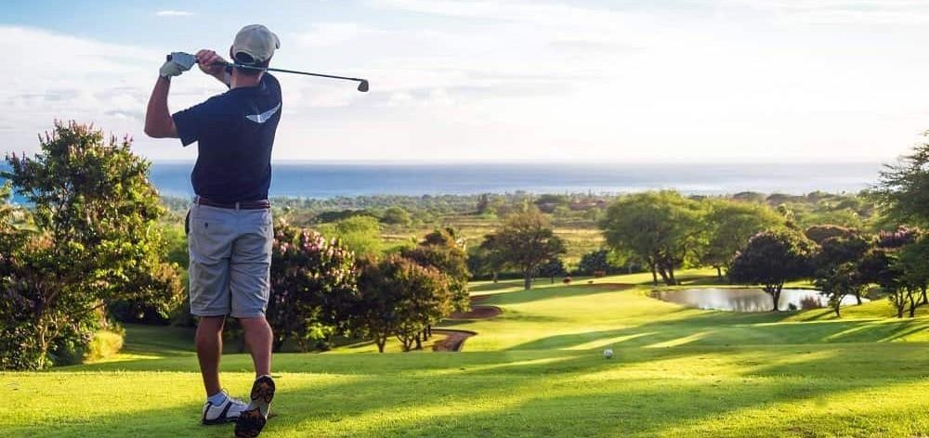

CASINO LLoret de Mar
If you want to spend a special evening at the casino, do not hesitate to visit the Gran Casino Costa Brava in Lloret de Mar. This 16,000 m2 building offers areas reserved for machines and gaming tables where tournaments are organized. international.

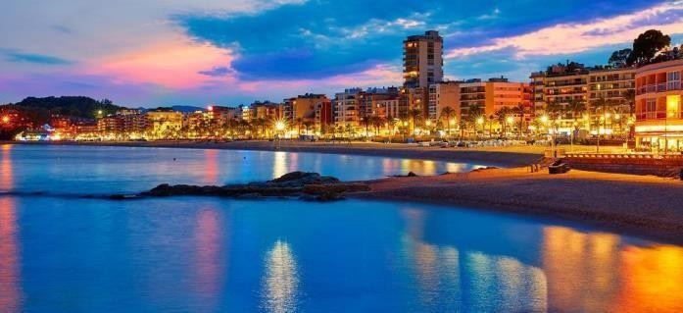
Golf in a breathtaking environment! This beautiful natural environment guarantees that in the surroundings of Lloret de Mar beautiful golf courses. Velvet greens, ideal for perfecting your swing and improving your handicap, amid breathtaking coastline and mountains make for a first-class golf experience in an idyllic setting.
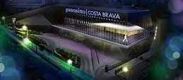

OUTDOOR ACTIVITIES
Costa Brava is a tourist destination renowned for its climate, its picturesque landscapes, its historical sites, its various sporting and leisure possibilities. Among the many activities that can be practiced, many are near our hotel: Beach, horse riding, hiking, trekking, mountain biking, sailing, water park, aquarium, bowling, climbing, bungee jumping, hang gliding, karting...

POOLS & SPAS

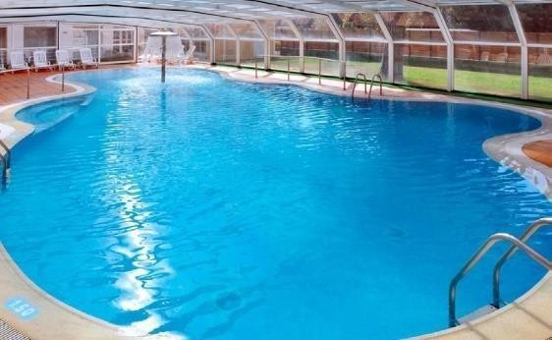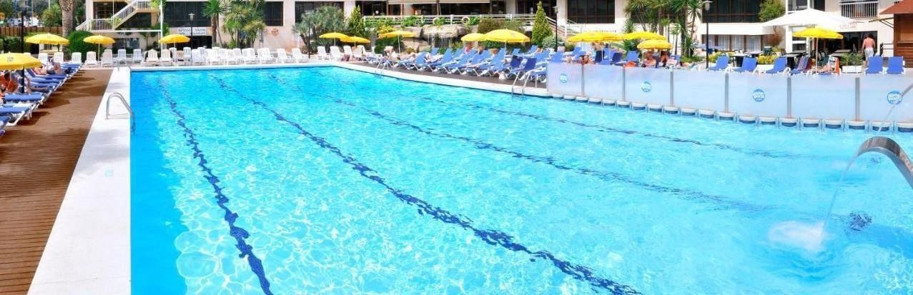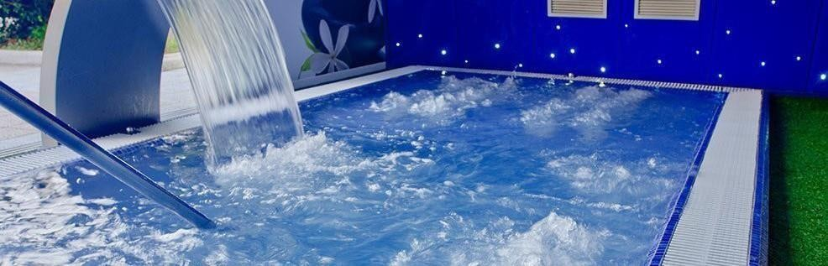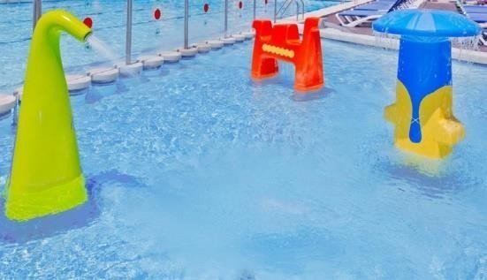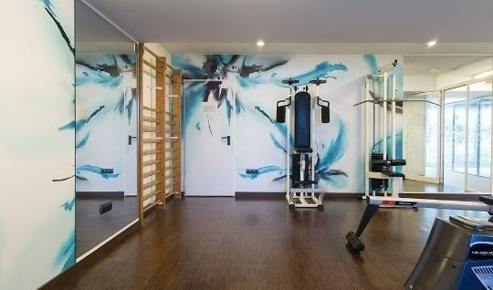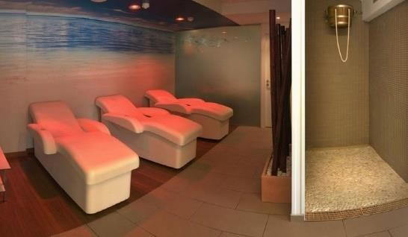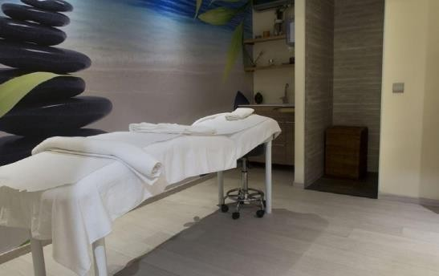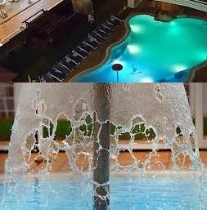Sensorial
SPA

Welcome to our Sensory SPA

Inspired by the most precious natural resources of the Costa Brava, our Sensorial Spa embodies pure rejuvenation and relaxation. The spa offers a range of personalized treatments that you will discover throughout your stay.

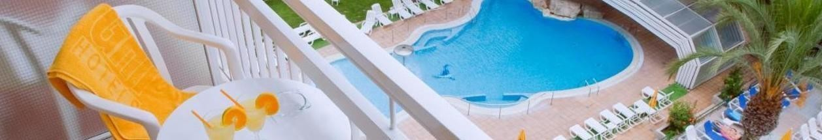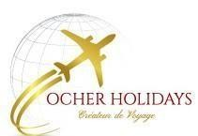Our luxurious and beautifully appointed suites all have furnished terraces or balconies, most with stun- ning ocean views. Benefiting from plenty of natural light, thanks to the floor-to-ceiling windows, they offer the ideal setting for relaxing and for a Passover in an authentic and exceptional setting.
PASSOVER 5784
ROOMS and SUITES

O A S I S P A R K & S P A
**** Luxury

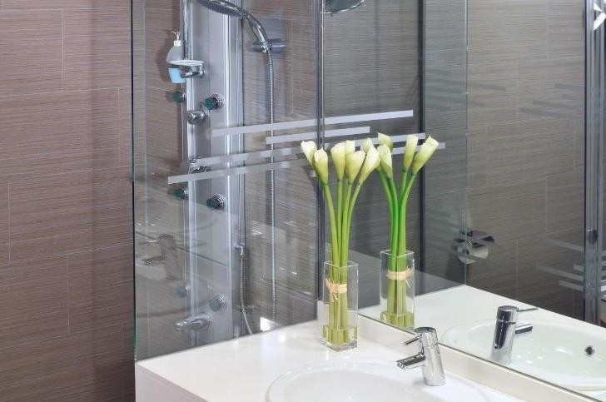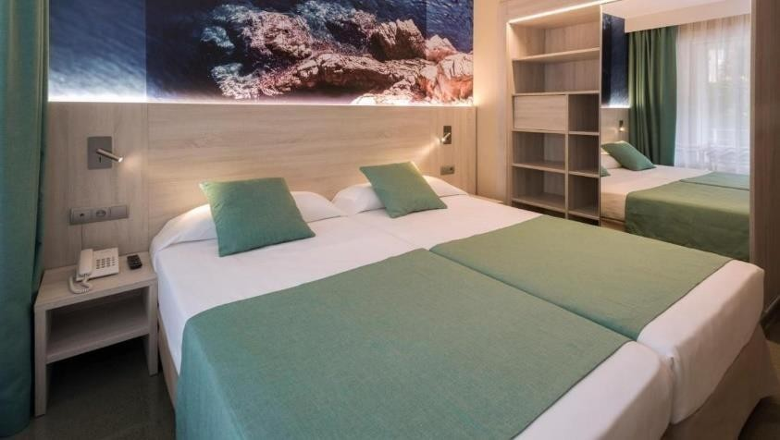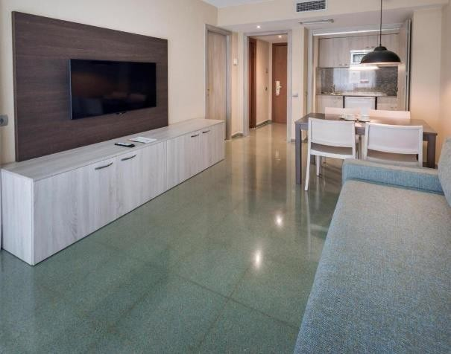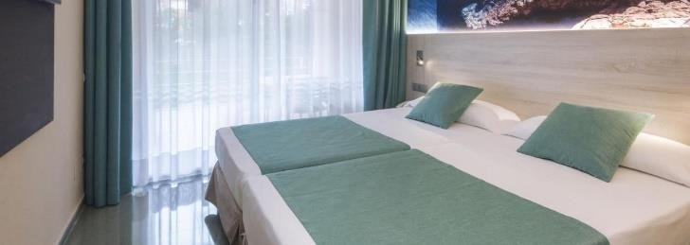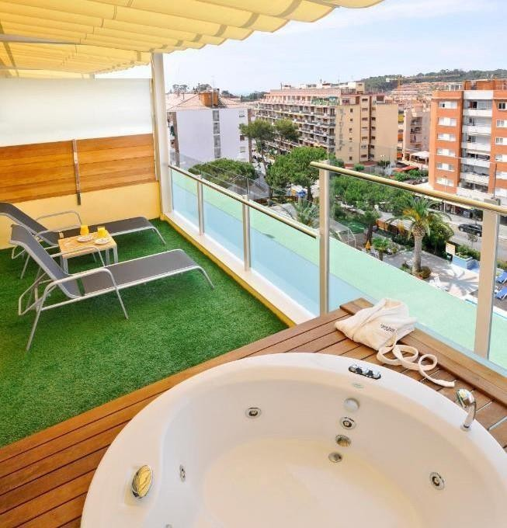

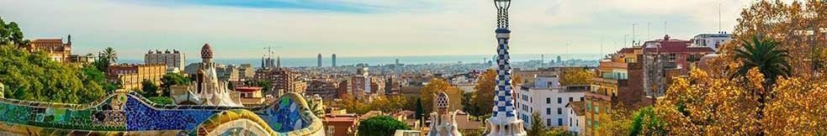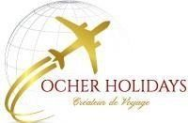COSTA BRAVA is a famous tourist destination for its climate, its picturesque landscapes, its historical sites, its various sporting and leisure possibilities.
PASSOVER 5784
EXCURSIONS & DISCOVERIES
Among the many activities that can be practiced, many are near our hotel: golf, horse riding, hiking, trekking, mountain biking, sailing, water park, aquarium, bowling, climbing, bungee jumping, hang gliding, karting...
BARCELONA
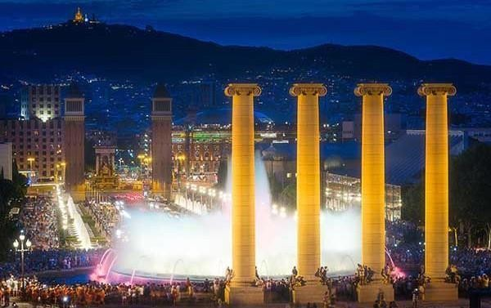
Barcelona is a peaceful city very pleasant to visit, where the sun is there all year round.
We will follow in the footsteps of our Jewish ancestors, they will tell you with passion the singular and fascinating history of the Jewish community in Spain over the centuries, and will make you discover unknown Barcelona, unusual places much more than the usual tourist guides. couldn’t do it..
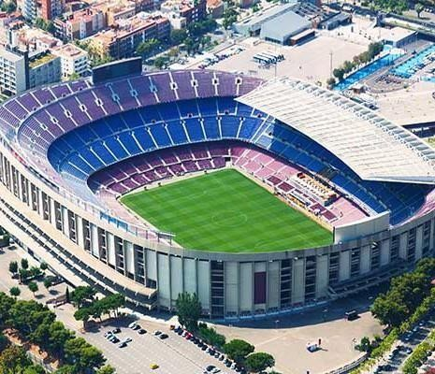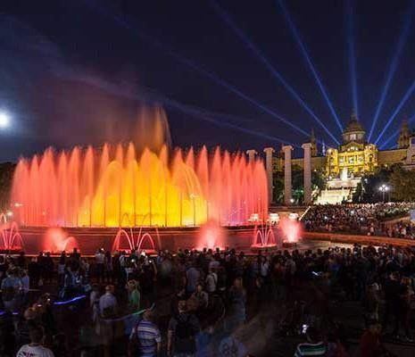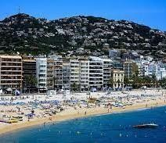

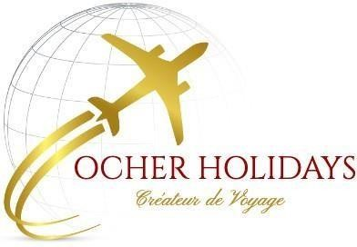HOLIDAYS
COVID 19 : Presence of Dr. E. DAYAN - Possibility of antigenic test throughout the stay

+ 33 6 52 19 20 67
+ 1 347 707 48 48
+ 972 54 809 66 86
WWW.OCHERHOLIDAYS.COM
ocherholidays@gmail.com

